Soda Lime Information and Instructions
How soda lime works
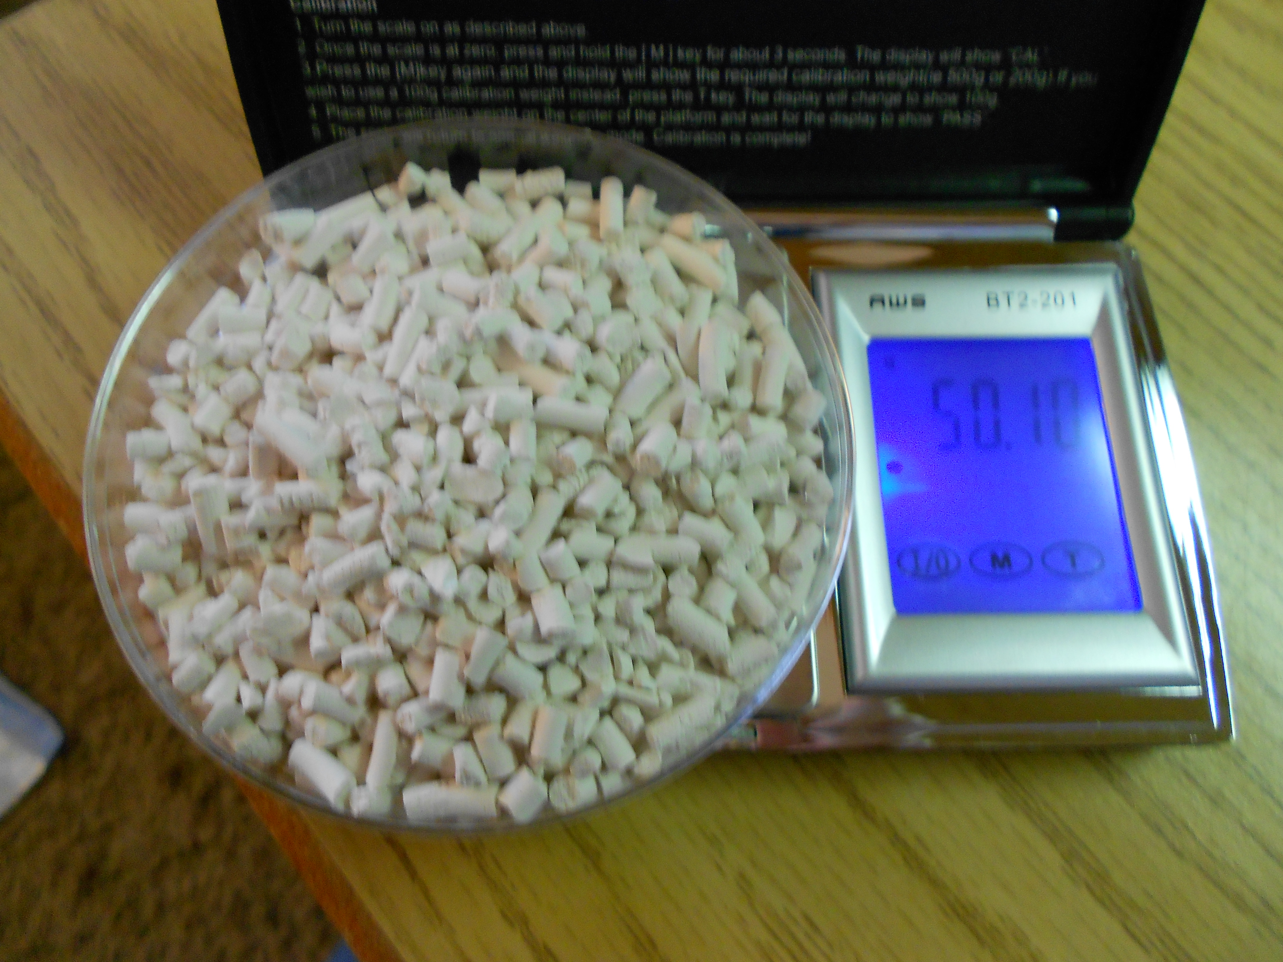
Soda lime is a mixture, consisting predominantly of calcium hydroxide (typically 70-90%) together with small amounts of potassium hydroxide (3%) and sodium hydroxide (1%). Soda lime absorbs both CO₂ and water vapor. In Carbon TIME we are using soda lime to track the mass of CO₂ molecules during respiration of plants, animals and fungi.
The reaction can be considered water mediated and base catalyzed (NaOH), and results in the conversion of CO₂ to calcium carbonate. The overall reaction is: CO₂ + Ca(OH)₂ → CaCO₃ + H₂O + heat (in the presence of water). Ethyl violet indicator may also be present which will let you know that the soda lime is spent and no longer absorbs CO₂ and H₂O. Potassium hydroxide and sodium hydroxide are mainly responsible for the corrosive nature of soda lime.
Fun fact: The Navy uses soda lime in submarines to scrub CO₂ from the air to avoid CO₂ poisoning!
Instructions for using soda lime
In experiments: Students may argue that the soda lime is absorbing CO₂ and water from the ambient air instead of from respiration of the sample (plant, animal, fungi) in the chamber. So, teachers may choose to use empty chambers with just soda lime as a control to account for this factor. We found that in a sealed 2.25 L (Ziplock plastic) container the soda lime gained < 0.06 g of weight. We think this suggests that control soda lime treatments will be successful and useful in accounting for CO₂ (and water vapor) that is not associated with the sample. And nearly all of the weight gain of soda lime in the investigation can be attributed to the sample.
Handling*: Soda lime will irritate skin, so wear lab gloves when working with it, and wash skin after contact. Lab goggles are also advised if possible. Avoid inhaling soda lime dust. Also avoid eye contact and immediately irrigate eyes thoroughly if contact occurs. Do not ingest soda lime, seek medical attention if ingestion occurs. When not using soda lime, store it in a clean dry environment at room temperature, keeping the container closed tightly. Avoid freezing and direct sunlight.
*Teachers may choose to do the soda lime investigations as a demonstration.
Disposal: Reuse soda lime multiple times until it turns a violet color. Follow your school’s guidelines for chemical waste disposal. If your school does not have guidelines already for disposal of chemicals, place the spent soda lime in a sealed plastic bag and place it in the garbage. The soda lime will eventually convert to naturally occurring minerals with no prolonged damage to animal or plant life. Do not place the soda lime in water without a fume hood and goggles, as an exothermic reaction will result.

